As much as possible – Extreme value tasks in Geometry
Andreas Ulovec
Abstract. Most people are familiar with extreme value tasks: “What is the largest triangle you can conscribe in a circle?” or “What is the largest rectangle you can conscribe in a rectangular triangle?” and so on. Usually, these tasks are solved with the help of calculus, specifically with derivatives. This of course gets you a correct result, but it does not tell you much about the geometrical situation behind it. We will show another approach by making constructions with the Dynamic Geometry Software GeoGebra, then analyze these constructions to get an idea of the situation and even an approximation of the solution. Only then we will check it with calculus.
1 A typical extreme value task
An extreme value task is the problem to find one or more local or global maxima or minima of a function (or several functions) within given ranges. Let’s have a look at a typical extreme value task:
Task: We have a rectangular triangle with side length a = 3cm, b = 4 cm, c = 5cm. What are the dimensions of the rectangle with the largest area that you can conscribe into the triangle, when one of the rectangle sides lays on side c of the triangle?
Would your first guess be “a square”? Well, let’s have a look. First we simply use GeoGebra to construct the triangle and inscribe the rectangle:
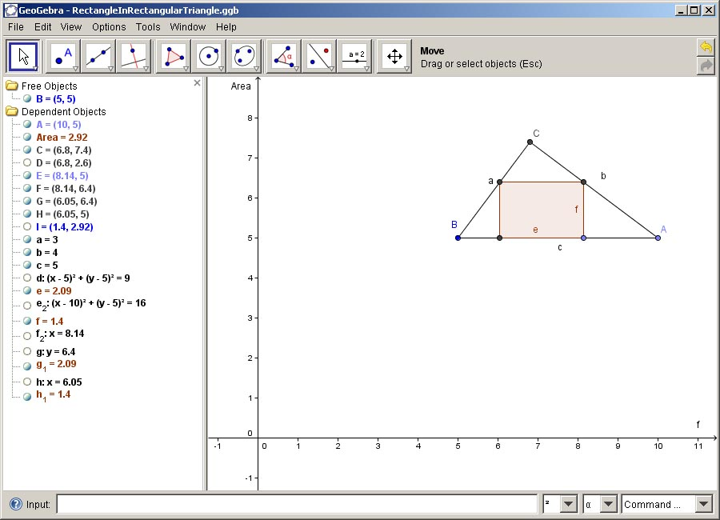
Figure 1: Constructing the rectangle within the triangle
2 DGS instead of calculus
Changing the size of the rectangle and looking at the value for the area (named Area in the algebra window) does only reveal that if the rectangle is very slim it has a much smaller area than if it is near the dimensions of a square. Let’s be a bit more exact and have a look at the function describing the area of the rectangle. Now this would of course be $\text{Area}(e,f)=e⋅f$. We now have a function with two variables, but they are not independent from each other! If we change e, the value of f changes accordingly. We can reduce this to a function $\text{Area}(f)$. For a calculus analysis, we would now determine the exact term for the function Area, and then calculate the derivative etc. For now, we do not need to do that, because we can simply read the value of the function Area in the algebra window! To find the maximum of this function (or at least to get a good approximation of the maximum), we can draw the graph of it. How can we do that without knowing the function term? Well, as just said, we can read the function value in the algebra window, i.e. for each given value of f we can construct the point$P=(f,\text{Area}(f))$and hence get one point of the graph:
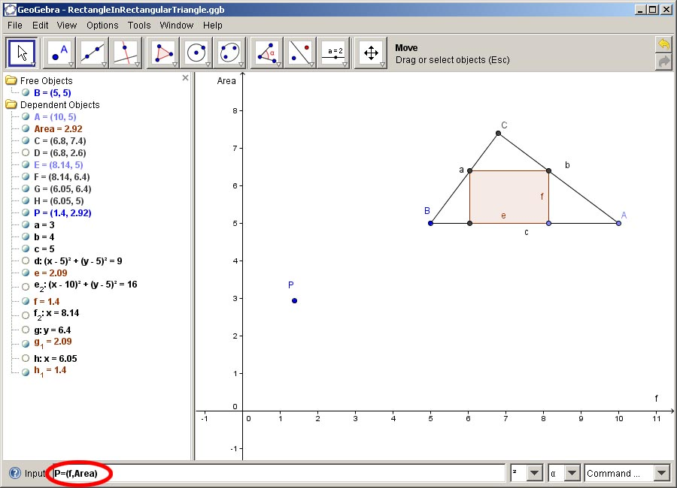
Figure 2: Having one point of the graph ...
How do we construct the whole graph, again without knowing its term? We just use the trace on function of GeoGebra and change the size of the rectangle by pulling on the point, as we did above. This results in the following:
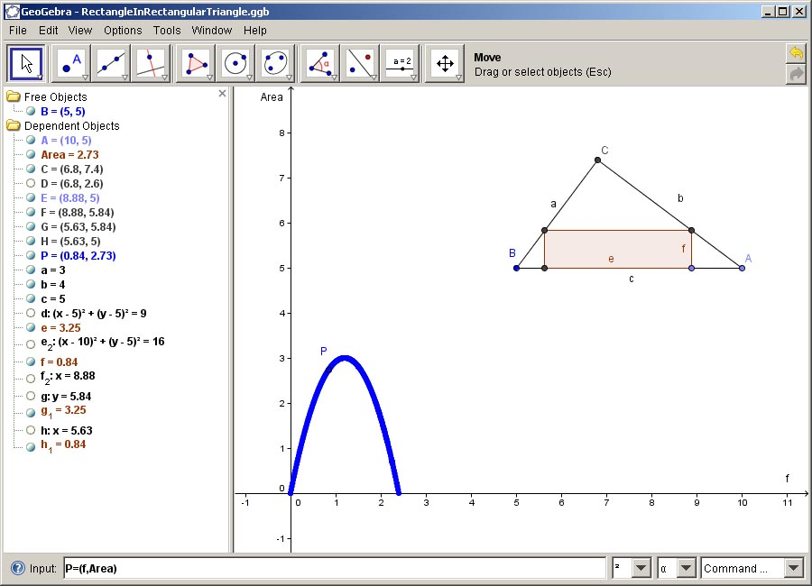
Figure 3: Trace the point P, and we get the graph
One look at the graph shows us that the maximum is at about$f≈1$. To check this and to find out the exact value, we now revert to our calculus knowledge. First, we need to find the term of the function$\text{Area}(f)$. We already know that$\text{Area}(f)=e⋅f$. Now we take a look at the geometric construction and use the intercept theorem to get a relation between e and f. For that, we first name some of the line segments:
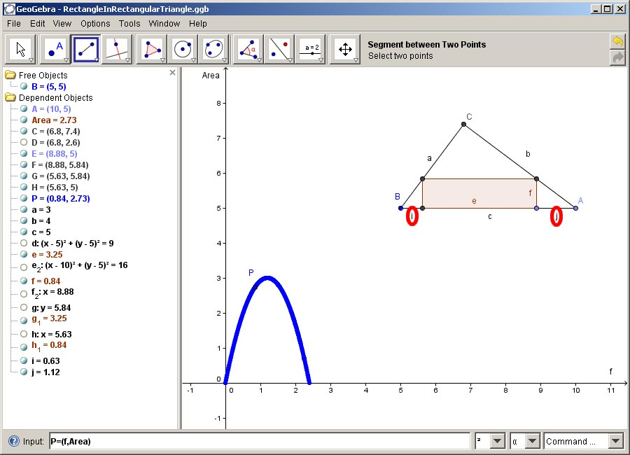
Figure 4: Naming the line segments
3 Time for calculus
Now we can easily use the intercept theorem, which gets us the following relations:
$$i:f=a:b, f:j=a:b$$
We also know the dimensions of the triangle, i.e. we know that
$$a=3, b=4, c=5$$
From the construction, we can also easily see that
$$i+e+j=c$$
This leads us to the following:
$$\frac{3}{4}f+e+\frac{4}{3}f=5$$
From which we can easily derive a relation between e and f, namely
$$e=5−\left(\frac{3}{4}+\frac{4}{3}\right)f=5−\frac{\text{25}}{\text{12}}f$$
Now we can finally write the equation for the function Area:
$$\text{Area}(f)=e⋅f=\left(5−\frac{\text{25}}{\text{12}}f\right)⋅f=5f−\frac{\text{25}}{\text{12}}f^{2}$$
To get the maximum of this function, we first calculate the derivative:
$${\text{Are \{}a}^{'}(f)=5−2⋅\frac{\text{25}}{\text{12}}f=5−\frac{\text{25}}{6}f$$
Now we set${\text{Are \{}a}^{'}(f)=0$and calculate the value for f:
$${\text{Are \{}a}^{'}(f)=0=5−\frac{\text{25}}{6}f⇒5=\frac{\text{25}}{6}f⇒f=\frac{6}{5}=1\text{.}2$$
A look at the graph confirms that the function has indeed a maximum at$f=1\text{.}2$. To confirm this analytically, we can calculate the second derivative at$f=1\text{.}2$:
$${\text{Are \{}a}^{''}(f)=−\frac{\text{25}}{6}<0$$
The second derivative at$f=1\text{.}2$is smaller than 0, i.e. the function really does have a maximum at$f=1\text{.}2$. Now we only need to calculate the corresponding value of e, using the equation that we obtained above:
$$e=5−\frac{\text{25}}{\text{12}}f=5−\frac{\text{25}}{\text{12}}⋅\frac{6}{5}=5−\frac{5}{2}=2\text{.}5$$
So the final answer to our question would be: The rectangle with the largest area that you can conscribe into a rectangular triangle with side length a = 3cm, b = 4 cm, c = 5cm has the dimensions$e=2\text{.}5$cm and$f=1\text{.}2$cm. Particularly, it is not a square!
Using the same methods, one can also solve the following tasks:

- You want to fence off a rectangular area along a wall. There is enough material to build a fence with a length of 20 m. How do you have to choose the dimensions of the rectangle so that you can fence off the largest possible area? How large is that area? How large would the area be if you would build not a rectangle, but a semicircle?
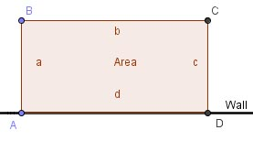

- Inscribe an isosceles triangle in a square, as shown below. How do you have to choose the distance f so as to achieve the maximum area of the triangle?
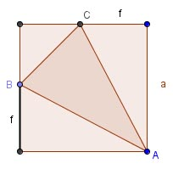
- Construct the net of an (open) cube as shown below (a = 3 cm). How do you have to choose the distance m so as to achieve the maximum volume of the cube (note that we are not looking for the maximum area of the net)?
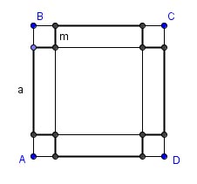
4 Final remarks
Many real-life applications (see e.g. [1]) need some sort of optimization. Some problems are fairly easy to solve, particularly those with only one parameter. Others are trickier, and fairly often there is no unique solution to a problem. In a lot of situations, modelling and/or simulating helps to obtain at least a good approximation for optimal values (that’s basically just what we did above in GeoGebra). More modelling can be found in [2].
Bibliography
[1] John Andersen et al. Math2Earth – Bringing Mathematics to Earth, Prvokruh Publishing House, Prague, 2010, ISBN 978-80-901470-2-7
[2] Vladimir Georgiev et al. MEETING in Mathematics, Demetra Publishing House, Sofia, 2008, ISBN 978-954-9526-49-3
Dr. Andreas Ulovec
Faculty of Mathematics
University of Vienna
Nordbergstrasse 15
AT – 1090 Vienna
e-mail: Andreas.Ulovec@univie.ac.at

