The Palazzone

To arrive at the Palazzone, the 16th century Villa Passerini, you should take the usual road for access to Cortona and just before coming into the town you will find a place where three roads meet; here you take the little road going down to the right which has a yellow sign saying "Il Palazzone"; taking this road that leads to Contesse you will come to a fork where there is another yellow sign and go left for the Palazzone.
Cardinal Silvio Passerini (1469-1529) oversaw the construction of the imposing princely Villa. He was a very loyal supporter of the Medici family as a result of which he had a brilliant career to begin with; however in the last years of his life up to his death luck turned against him.
The building of the Palazzone together with the Villas Piazzano, Bettolle and Petrignano is an exemplary proof of his ambition for wealth that he liked to show by undertaking very prestigious works where he used the wealth he had accumulated as Commissioner and Envoy for Perugia and Umbria.
There is no document to tell us exactly when building of the Villa began but we can be almost certain the work took place between 1521 and 1527. Passerini had little time to enjoy it: the years from 1526 to 1529 were very sad for him because his political fortunes were in decline.
The plan for the Palazzone was drawn up by the Perugian painter, architect and poet Giovan Battista Caporali (1476?-1560?), a follower of Perugino, friend of great artists of the period and Galeazzo Alessi's master.
The interior designer, perhaps with Caporali, was Tommaso Bernabei called il Papacello (+1559) and known as Signorelli's best pupil and for having worked in Rome with Giulio Romano and later, in Perugia, in the Palazzo dei Priori.
The building was completed in these stages and when il Papacello decorated the Salone (the great hall) the last part had not yet been built as can be seen from the fresco representing the Battle of Trasimeno.

Description
The exterior
The position is wonderful, cut into a hill-side about half way between Cortona and S.Angelo a Metelliano; the panorama of tall trees, cypresses, meadows, rocks at the back and the Cumula spring near the tower extends magnificently as far as Val D'Esse and Valdichiana. The Fonte Cumula (which in old maps is written in various way: Comula, Comeli, Cornelia ) gave its name to the area where the Villa was built.
Seen from the outside you would have difficulty in believing the Villa was built in the 16th century; the appearance, especially the high tower with double crenellations, is medieval. The whole construction is more like a fortress than a Villa. The earlier style of the Palazzone has unquestionable dignity because of its solidness and compactness: it is austere, severe without decoration.
The structure covers 856.280 sq.m. and is 70 m. long and 27 m. wide. The tower is 48 m. high, the Salone measures 15x7.20 m. The internal courtyard is 17x10 m., with a portico and an elegant Reinassance well.
A flight of stairs in herring-bone patterned brick leads to the stone main gateway with the Passerini coat-of-arms in the keystone of the arch as the later design which in the upper part contains the emblem of the Medici.
The interior has sombre severe architectural lines like the exterior but a little more modern. The ground floor is for the most part stables; the main rooms are on the piano nobile: the Salone, another called the Billiard room, the cardinal's bedroom and the chaple.
The Salone is the most prestigious room: it is decorated high up with 16 frescos by il Papacello each 2x2 m. showing episodes of history and Roman legend. Starting from the left looking towards the fireplace they are:
1) Lucretia being rapted by Sesto Tarquinio
2) Lucretia killing herself in the presence of her husband, Collatino, and L. Giunio Bruto
3) Marco Curzio throwing himself armes on horseback into an abyss that has open up in the Roman Forum
4) The head of Asdrubale defeated near the Metauro being thrown into the camp of his brother Annibale in Apulia
5) The judgement of innocent Virginia
6) Virginia being killed by her father, Virginio
7) The Battle of Trasimeno: this fresco is of great documentary value both for the view of the Palazzone and how Cortona looked in the first half of the 16th century: the rock of Girifalco can be seen before the building of the Medici fortress ordered by Cosimo I, the village of S. Domenico with its walls and gate, the recently completed church of S. Maria del Calcinaio and a partial view of the village of S. Vincenzo
8) Cincinnato being elected dictator
9) L. Giunio Bruto at the temple of Delfo
10) The struggle between Orazi and Curiazi
11) The loyalty of M. Furio Camillo
12) The killing of Tarquinio Prisco by the sons of Anco Marzio
13) Curio Dentato answering the Sannite ambassadors
14) Clelia and her companions fleeing from Porsenna by crossing the Tiber
15) Muzio Scevola burning his hand before Porsenna
16) P. Orazio Coclite defending the Ponte Sublicio
These frescos are not in themselves masterpieces but are interesting for their narrative and compositional fluency, the movement in the scenes, their dramatic force and vibrant colours. They are a good example of the great Reinassance tradition for the decoration of Villas.
In the lower part of the Salone are twelve trompe l'oeil paintings very beautiful for their realism, series of columns, landscapes, visual effects and warm tones. The group of the Laocoon should be noted, a reprodution of the classical sculpture at that time recently discovered.
The cardinal's bedroom is situated at the back, towards the east and is decorated with trompe l'oeil colomnades and rustic scenes. In the centre of the ceiling is Apollo on his four horse chariot, surrounded by the signs of the zodiac and the four seasons.
There are numerous interesting pieces of forniture and works of art in the Palazzone: original paintings and copies, box seats, 16th century cabinets and seats, large mirrors, trinkets, clocks, valuable beds, divans and curios of all kinds; Etruscan funeral urns, lots of bayonets and guns and African souvenirs of Count Lorenzo Passerini who lived and worked as an engineer in Angola up to 1960.
There is a beautiful internal courtyard with a Reinaissance portico and a central well and an open portico at the back of the building with an Italianate garden.
The chapel contains Signorelli's last work, The Baptism of Christ , a fresco not completed by him because while painting the great artist fell from the scaffolding: the work was finished by apprentices from his workshop.
Today the building belongs to the Scuola Normale Superiore and was donated in 1964 by Count Lorenzo Passerini and the S.N.S. directed the restoration. The nature of the building requires the S.N.S. and guests to observe the rules laid down for the safeguard of the country's cultural heritage. These rules are explained on the back page.

Useful numbers
Porteris ladge(tel e fax)
O575/630378
Secretery for conferences
O575/630378
Scuola Normale (switchboard)
050/509111
Scuola Normale (fax)
050/563513

RULES TO BE OBSERVED DURING A STAY AT THE PALAZZONE

Arrivals and departures
Guests and those participating in conferences that begin on a Monday and end in a Friday should note that the attendance of door-keepers is guaranteed on Saturdays up to 2 p.m. and on Sundays from 2 to 8 p.m.
Security rules
Guests will be given a key for the entrance door to be used after 8 p.m.
For the security of the guests and safeguard of the treasures in the Palazzone you are asked to always lock close the little gate used for entry at night. The alarm system working from 8 p.m. will be set in such a way as not to hinder guests entering and getting to their rooms.
Other rules
Guests are asked not to park cars on the lawn. Please do not lock your bedroom door in the morning so as to allow the cleaners to get in
Rooms available to guests
Anyone needing space for studying can use, also in the evenings, rooms situated on the ground floor set aside specially for guests. These rooms are not protected by an alarm system.

The S.N.S. thanks you for following these rules and wishes a pleasant stay to guests at the Palazzone.

Scuola Normale Superiore
Pisa

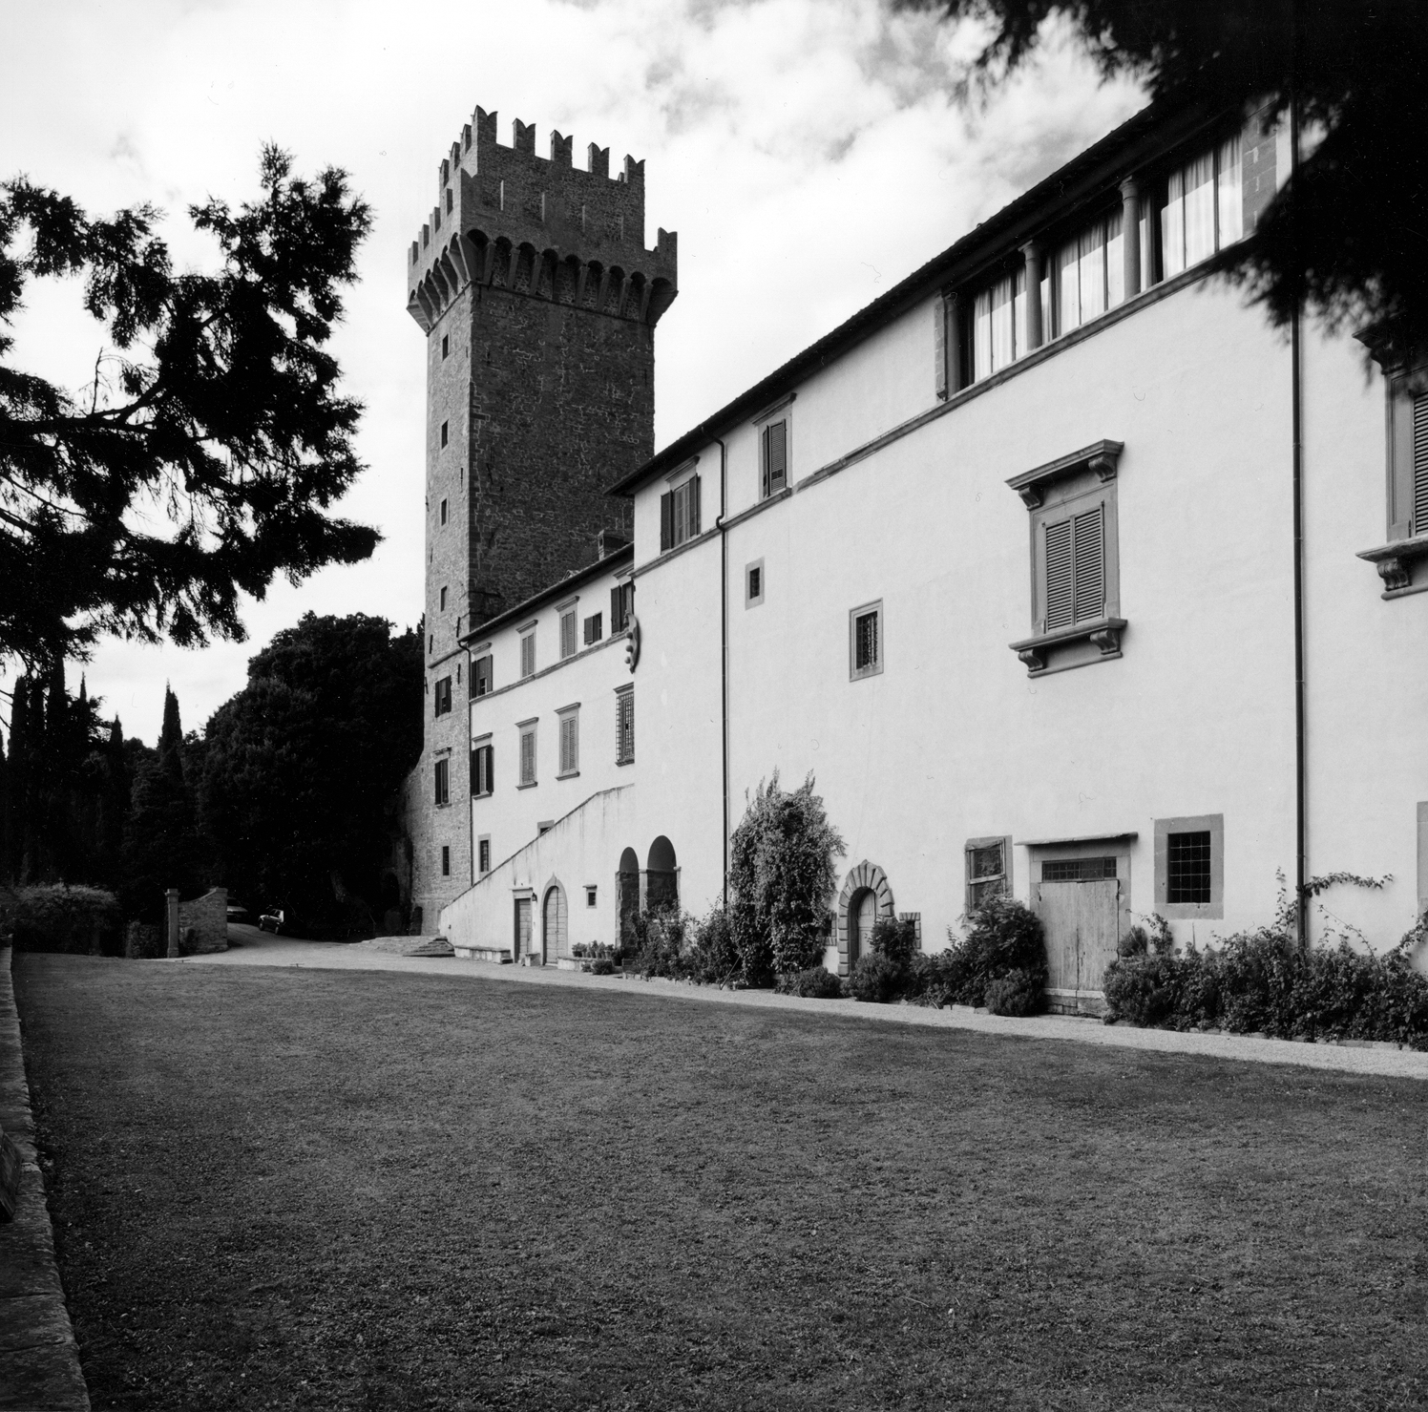

CORTONA
THE PALAZZONE

